Directions for Using Wave Pad Sound Editor
1. Google switch audio converter or type in this url and click download converter for windows.
http://www.nch.com.au/switch/index.html .
You might be prompted to check other downloads. If so, check the box next to wave pad; otherwise, google wave pad audio editor or type in this url. http://www.nch.com.au/wavepad/index.html. Download it onto your computer. This is a free trial; download it again if necessary.

2. Click on wavepad. Click on add file.
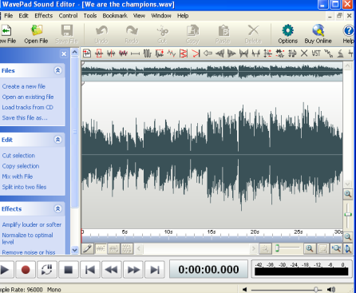
Select your music file on your computer. It will now be in the wavepad editor.

3. You will edit no more than 30 seconds of it. Select the play arrow and decide what part you what part you want to copy.

4. Place your cursor in the top left hand corner and grab the knob. Drag it to the start spot. A red line will appear.
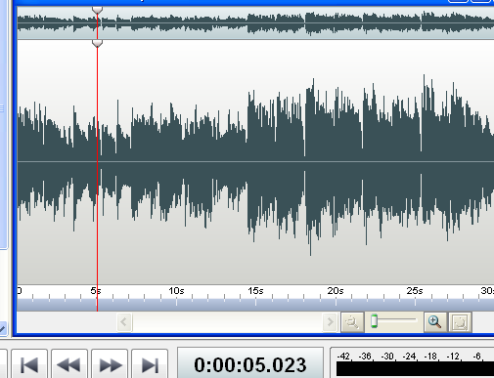
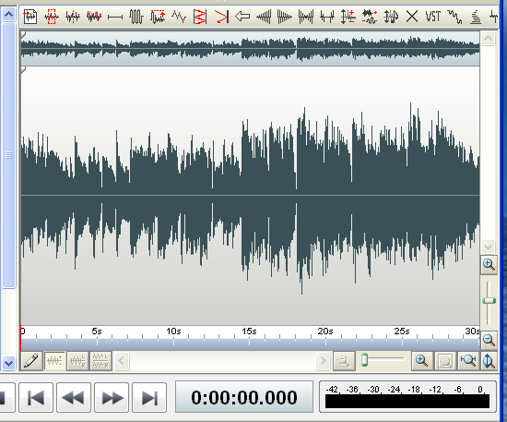
Place cursor here and drag to the right. A red line will appear as in the next illustration.
5. Place your cursor in the middle of the red line and drag it until you reach the end of what you want to copy. You will see it being highlighted.
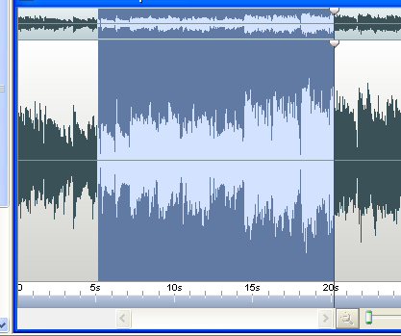
6. Click on edit trim start. Click on edit trim end.
7. Click on file, save file as, name it, select the type of file, then save.
NOTE: Wave pad will expire. Delete it from control panel and reinstall it.

